**Name :** *Saad Bin Munir*

**Batch Code :** *LISUM06*

**Submission Date :** *23 February 2022*

**Submitted to:** *Data Glacier*

**Deployment on Flask**

# **Writing Flask Application**

# **Writing template code**

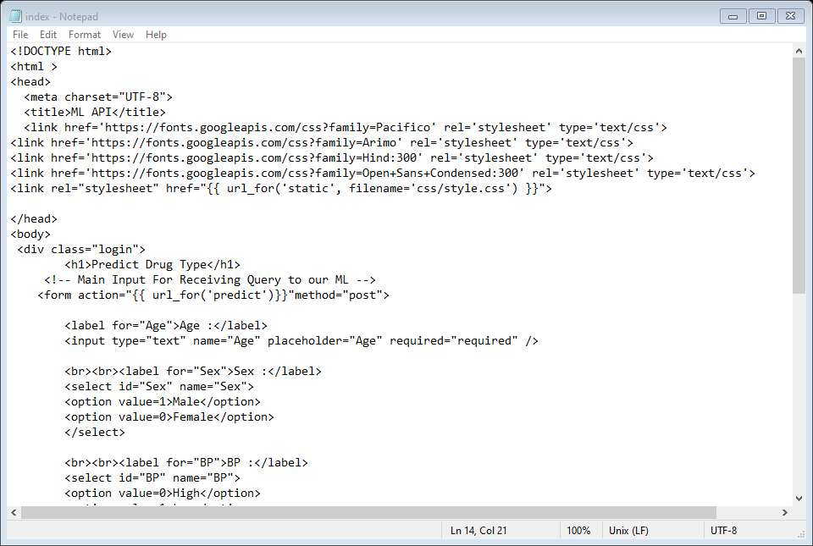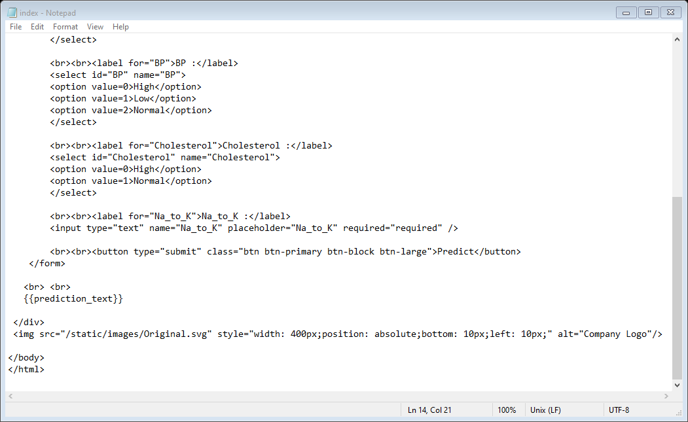

# **Running Flask Application**

# **Open link in Browser**

# **Test Model and Get results**

